Activity No 1.Finance Club Event “Money management”

Title of the Event | Finance Club Event “Money management” | 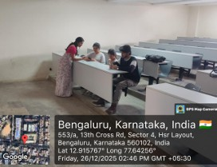
Day and Date | 26.12.25
Venue (With all details ) | Roon No-308
In collaboration with ( if any) | -
Details of Resource Person With Designation | Asst.Prof. Ritu U | 
Organizing Department/Coordinators | Business Management . Asst.Prof. Ritu U
Course and semester | MBA I Semester
No of Students & Faculty Participants | 3

Coordinator HoD Vice-Principal Principal

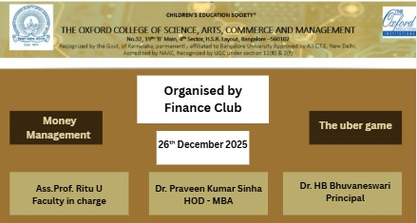

Introduction
On December 26, 2025, the Finance Club hosted an interactive session from 3:00 PM to 3:30 PM focused on the realities of the modern gig economy. The centerpiece of the meeting was The Uber Game, an immersive simulation created by the Financial Times.

Description of the Activity
The primary objective of the session was to illustrate how an Uber driver earns and manages money in a high-pressure environment. Students had to make critical real-world decisions, such as whether to pay for car repairs, how to handle difficult passengers, and when to take breaks. This highlighted the difference between gross earnings and net profit.

Outcome of the Activity
During the 15-minute simulation, the concept of "urgency" played a major role. Students experienced the stress of hitting financial targets—such as a $1,000 mortgage payment—within a strict timeframe. This exercise provided a practical lesson in cash flow management and the psychological toll of financial instability, as students realized that working more hours doesn't always guarantee financial security if expenses are not tightly controlled.

Conclusion
The session concluded with a brief reflection on the trade-offs between flexibility and financial risk. By experiencing the life of a driver firsthand, club members gained a deeper appreciation for the importance of emergency funds and disciplined budgeting. The event successfully bridged the gap between abstract financial concepts and the lived reality of millions of workers, leaving students with a more nuanced understanding of how to manage money in an unpredictable economy.

